LCM Specification
Company Name: |  |  | Inquiry Date:
Contact Information: | Name: |  | E-mail:
Contact Information: | TEL: |  | FAX:
Application: |  |  | Est. Q’ty:
M.P. Schedule: |  |  | Target price:

*1. Module Structure | □COB / □SMT |  |  |  |  | □COG |  |  |  |  | □COF / □TAB
*2. Dimensions: | 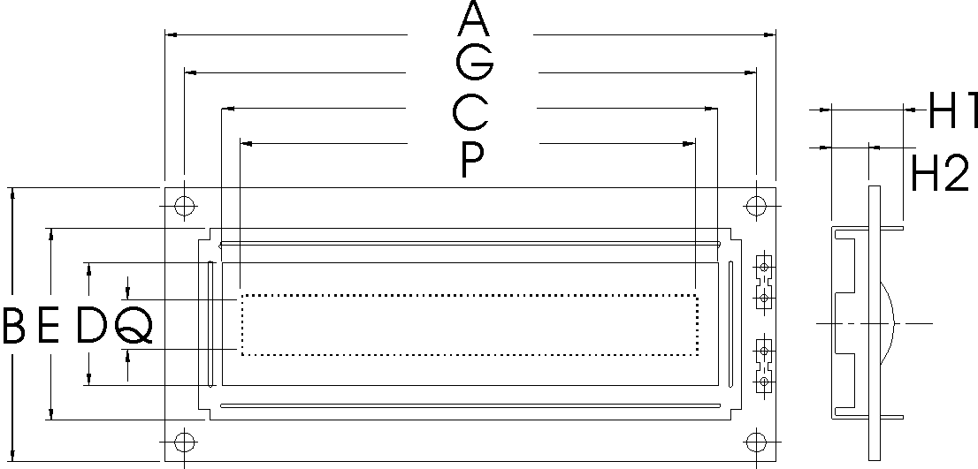 |  |  |  |  | 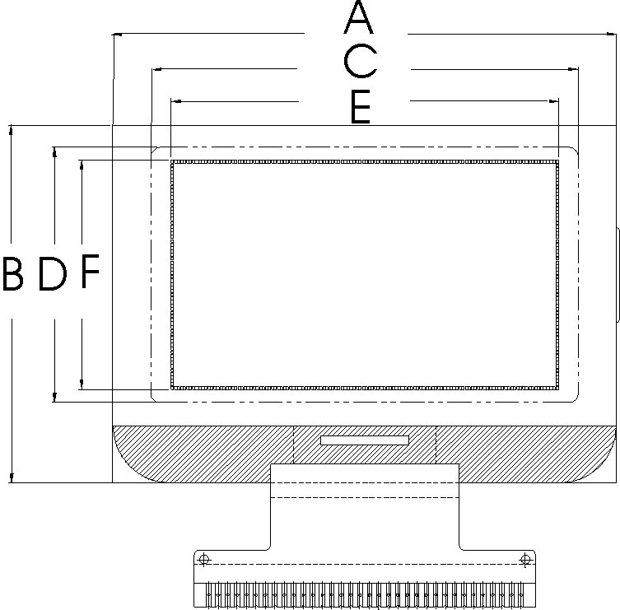 |  |  |  |  | 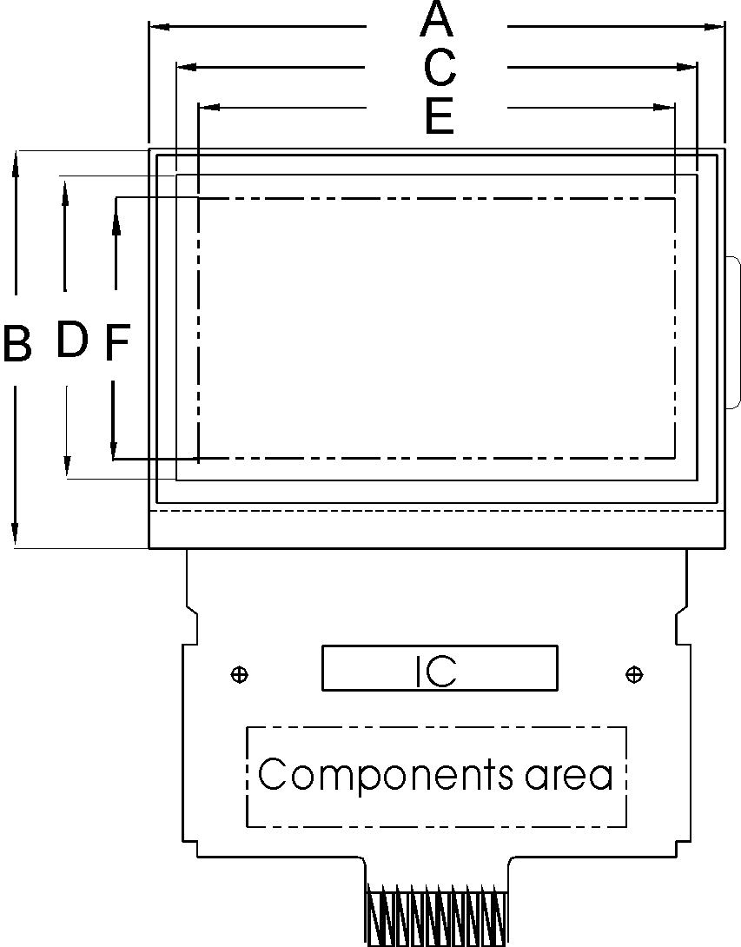
*2. Dimensions: | *Module Outline: (A) X (B) mm
*2. Dimensions: | *Viewing Area: (C) X (D) mm
*2. Dimensions: | Active Area: (E) X (F) mm
*2. Dimensions: | *Distance between mounting holes: (G) X (H) mm
*2. Dimensions: | Diameter of mounting holes: (M) mm
*2. Dimensions: | Total thickness: (H1) mm
*2. Dimensions: | *Upper thickness: (H2) mm
*3. Display Contents | □Segment type: segments
*3. Display Contents | □Character type duty |  |  |  |  |  |  | □Graphic type duty
*3. Display Contents | Resolution= characters * lines |  |  |  |  |  |  | Resolution= dots* dots
*3. Display Contents | Character size=W * H mm |  |  |  |  |  |  | Dot size= W * H mm
*3. Display Contents | Character size=W * H mm |  |  |  |  |  |  | Dot pitch= W * H mm
*4. LCD Specification | LCD type | □TN | □HTN | □STN |  |  | □FSTN |  |  | □Color STN |  |  | □Others
*4. LCD Specification | Image | □Positive |  |  |  |  |  |  | □Negative
*4. LCD Specification | Background Color | □Gray |  |  | □Yellow green |  |  |  | □Blue |  |  |  |  | □Black(FSTN)
*4. LCD Specification | Background Color | □White(FSTN) |  |  | □Other
*4. LCD Specification | Polarizer | □Reflective |  |  | □Transflective |  |  |  | □Transmissive
*4. LCD Specification | Polarizer | □Antiglare |  |  | □Anti-UV |  |  |  | □3M-TDF |  |  | □Others
*4. LCD Specification | View direction | □6:00 |  |  | □12:00 |  |  |  | □3:00 |  |  |  |  | □9:00
*4. LCD Specification | Printing | □None |  |  | □Included

LCM Specification
*5. Backlight | □None
*5. Backlight | □LED |  |  | □Array |  | □Edge |  |  | Color
*5. Backlight | □EL |  |  |  |  |  |  |  | □Yellow green |  |  |  |  |  |  |  |  | □Green |  | □Amber
*5. Backlight | □CCFL |  |  |  |  |  |  |  | □Red |  |  |  | □Blue |  |  |  |  | □White |  | □Orange
*5. Backlight | □Built-in Inverter |  |  |  |  |  |  |  | □Others
*6. Temperature Range | Operating: ℃~ ℃ |  |  |  |  |  |  |  | Storage: ℃~ ℃
7. IC | Controller | □Built-in controller IC, with DRAM K bites
7. IC | Controller | □Built-in / font table for character display
7. IC | Controller | □Graphic display by ram mapping
7. IC | Controller | Interface: |  |  | □Serial | □Parallel bits |  |  |  |  |  |  |  |  |  | □12C |  | □Others
7. IC | Driver | □Segment driver □Common driver
7. IC | Booster | □Negative Voltage Converter □Positive Voltage Converter
*8. Electrical characteristics | Vdd= V, Idd= mA, Vee= mA, Iee= Ma VOP V
*8. Electrical characteristics | Built-in circuits: |  | □Booster |  |  |  | □T.C. |  |  |  | □V.R. |  |  |  |  |  | □Others
9. Connector | attached to PCB |  |  |  | □Rubber |  |  | □Heatseal |  |  |  | □TCP IC |  |  |  |  | □FPC |  | □Metal pins
9. Connector | LCM Interface |  |  |  | □None (through hole)
9. Connector |  |  |  |  | □Straight pin header |  |  |  |  |  |  |  |  | Pin Pitch mm  Pin number
9. Connector |  |  |  |  | □Right angle pin header
9. Connector |  |  |  |  | □Heatseal |  | □FFC |  |  | □FPC |  |  |  |  | □Connector
10. Frame | □None |  |  | □Metal |  |  |  |  | □Plastic |  |  |  |  |  |  |  |  | □Others
11. Special Request | □ESD □EMI
11. Special Request | □Reliability test, please specify:
11. Special Request | □Others:
12. Remarks

