LCD SPEC FONT
Company Name |  |  |  |  | Inquiry Date：
Contact  Information |  | Name： |  |  | E-mail：
 |  | TEL： |  |  | FAX：
Application |  |  |  |  | Est.Q’ty：
M.P.Schedule |  |  |  |  | Target price：
LCD INQUI RY Formant | 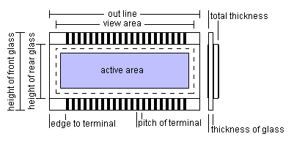 |  |  | Other： W x H mm  *View area： W x H mm  Active area：W x H mm  Front glass：W x H mm  Rear glass：W x H mm  *Glass thickness：  □0.4 □0.55 □0.7 □1.1 □Other mm
LCD INQUI RY Formant | Display mode | *□TN □HTN □STN □FSTN □color STN □Others  *Style：□Segment □Character x line □Graphic W x H dots  *Dot：W x H mm / Pitch：W x H mm  *Image：□Positive □Negative  *Background color：□Gray □Yellow green □Navy blue □White(FSTN) □Others  *View direction: □6:00 □12:00 □3:00 □9:00  Seal end on □Top □Bottom □Left □Right  Printing：□Nil □Front glass □Rear glass □Polarizer, in color
LCD INQUI RY Formant | Polarizer | *□Reflective □Transflective □Transmissive  *Front：□regular □antiglare □anti-UV □attached □separate  Rear：□attached □separate
LCD INQUI RY Formant | Drive method | Voltage： Min. V, Typical V, Max. V  *in reference to driver IC: , frame frequency: Hz,  *□Static drive □Multiplex drive：1/ duty cycle, 1/ bias
LCD INQUI RY Formant | Temperature | *Operating: ~ ℃  *Storage: ~ ℃
LCD INQUI RY Formant | Terminal contact method | *□Zebra □Heat seal □Pin □Others ; Terminal pitch: mm, pcs  □Attached □Separate
LCD INQUI RY Formant | Terminal contact method
  Terminal style: | □ | □ | □ | □ | □ | □
  *Pin style | □ | □ | □
  *Pin style |  | 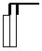 | 
LCD INQUI RY Formant | Others | □Data sheet attached □Drawing attached
LCD INQUI RY Formant | Remark

